PROGRAM DEFINITION
- Program untuk display transaksi journal

RELATED TABLES
 | Access
- GST_TRANS_HD  - GST_TRANS_JRN  - GSM_COMPANY  - GSM_DEPARTMENT  - GSM_TRANSACTION_CODE  - GSM_COA  - GSM_CENTER  - GSB_CODE_DT | - R  - R  - R  - R  - R  - R  - R  - R

INPUT PARAMETER
Parameter Name | Description
CCOMPANY_ID | Company Id
CDEPT_CODE | Department Code
CTRANS_CODE | Transaction Code
CREF_NO | Reference No.
CLANGUAGE_ID | Language ID

INITIAL PROCESS
Test
- Jalankan RSP_GS_GET_COMPANY_INFO dengan parameter, simpan hasil ke VAR_GSM_COMPANY
  - CCOMPANY_ID

FORM

USER INTERFACE

INITIAL VERSION
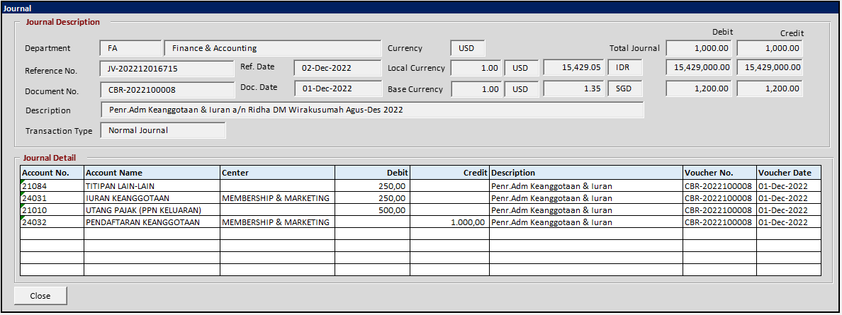

BUTTON DEFINITION
Button Name | Action
Close | Tutup Form

OUTPUT
Test

ROLES
Test

INITIAL PROCESS
Test
- Refresh form dengan RSP_GL_GET_JOURNAL_DETAIL dengan parameter:
  - CCOMPANY_ID
  - CDEPT_CODE
  - CTRANS_CODE
  - CREF_NO
  - CLANGUAGE_ID
- Refresh JOURNAL DETAIL grid dengan RSP_GL_GET_JOURNAL_DETAIL_LIST dengan parameter:
  - Journal ID
  - CLANGUAGE_ID

- Jalankan DISPLAY PROCESS

DISPLAY PROCESS

FIELD DEFINITION
Name | Field | Type | Validation
Journal ID | CREC_ID | Hidden
Department | CDEPT_CODE | Textbox, disabled
Reference No. | CREF_NO | Textbox, disabled
Ref. Date | CREF_DATE | Textbox, disabled
Document No. | CDOC_NO | Textbox, disabled
Doc. Date | CDOC_DATE | Textbox, disabled
Reference Period | CREF_PRD | Textbox, disabled
Description | CTRANS_DESC | Textbox, disabled
 |  | Textbox, disabled
Currency | CCURRENCY_CODE | Textbox, disabled
Local Currency (Base Rate) | NLBASE_RATE | Textbox, disabled
Transaction Currency Code | CCURRENCY_CODE | Textbox, disabled
Local Currency Rate | NLCURRENCY_RATE | Textbox, disabled
Local Currency Code | VAR_GSM_COMPANY.CLOCAL_CURRENCY_CODE | Textbox, disabled
 |  | Textbox, disabled
Base Currency (Base Rate) | NBBASE_RATE | Textbox, disabled
Transaction Currency Code | CCURRENCY_CODE | Textbox, disabled
Base Currency (Currency Rate) | NBCURRENCY_RATE | Textbox, disabled
Base Currency Code | VAR_GSM_COMPANY.CBASE_CURRENCY_CODE | Textbox, disabled
Total Debit (Original Currency) | NDEBIT_AMOUNT | Textbox, disabled
Total Credit (Original Currency) | NCREDIT_AMOUNT | Textbox, disabled
Total Debit (Local Currency) | NLDEBIT_AMOUNT | Textbox, disabled
Total Credit (Local Currency) | NLCREDIT_AMOUNT | Textbox, disabled
Total Debit (Base Currency) | NBDEBIT_AMOUNT | Textbox, disabled
Total Credit (Base Currency) | NBCREDIT_AMOUNT | Textbox, disabled
Transaction Type | CTRANSACTION_NAME | Textbox, disabled

JOURNAL DETAIL GRID DEFINITION
Name | Field | Type | Validation
Journal Detail ID | CREC_ID | Hidden
Account Type | CBSIS | Hidden
Account No. | CGLACCOUNT_NO | Label
Account Name | CGLACCOUNT_NAME | Label
Center | CCENTER | Label
D/C | CDBCR | Label | IF Debit > 0 AND Credit=0 THEN D  ELSE IF Debit=0 AND Credit > 0 THEN C  ELSE ‘’
Debit | NDEBIT | Textbox | Numeric with 2 decimal point
Credit | NCREDIT | Textbox | Numeric with 2 decimal point
Description | CDETAIL_DESC | Textbox
Voucher No. | CDOCUMENT_NO | Textbox
Voucher Date | CDOCUMENT_DATE | Textbox
DB (Local) | NLDEBIT | Label
CR (Local) | NLCREDIT | Label
DB (Base) | NBDEBIT | Label
CR (Base) | NBCREDIT | Label
Grid Mode
- Read Only

BUTTON MODE
Button Name | Mode
Close | Enabled

CR LIST

CR | Description | Notes
00  25-Oct-2023 | - INITIAL VERSION
 |  | </CR2>

TEMPLATE

VALIDATION
Field | Condition | Validation Message

ACTION

